MINIATURE CUT THE ROPE

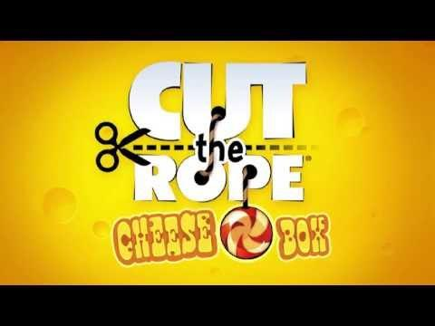

By:
SNEHA RAO GR
SNEHA SHAH

ACKNOWLEDGEMENT:

“Alone we can do so little, together we can do so much.” – Helen Keller
Acknowledgement is the most beautiful page in any project’s final pages. More than a formality, this appears to me the best opportunity to express our gratitude.
We have indeed put our share of efforts in this project. But it would never have been as fruitful without the support of all those who made this project a success.
We would like to say a big thank you from the bottom of our heart to the following people. Firstly, I would like to thank the school management and our principal – Mrs. Shantha Chandran for providing us an apt environment to accomplish the task. Next, I would like to express my gratitude to my teachers – Mrs. Manjula and Mrs. Suguna for their patient expert guidance and willingness to help whenever required. Last but not the least, We also appreciate the help provided by our parents in completing this project.

INTRODUCTION :

Our project is a game based on an existing game called ‘Cut the Rope’. The graphics of the game have been incorporated with the help of an external module, Pygame. It involves real life simulations like gravity and oscillations. The objective of this game is to get the candy to the bowl at the bottom of the screen, by cutting a rope, as the name suggest, and getting past some obstacles. On the way, there are stars for bonus points. All you have to do is to cut the rope ,collect all the stars, burst the bubble and escape traps to reach the bowl in the shortest time possible. We have incorporated the concepts of classes and objects, file handling, exception handling.
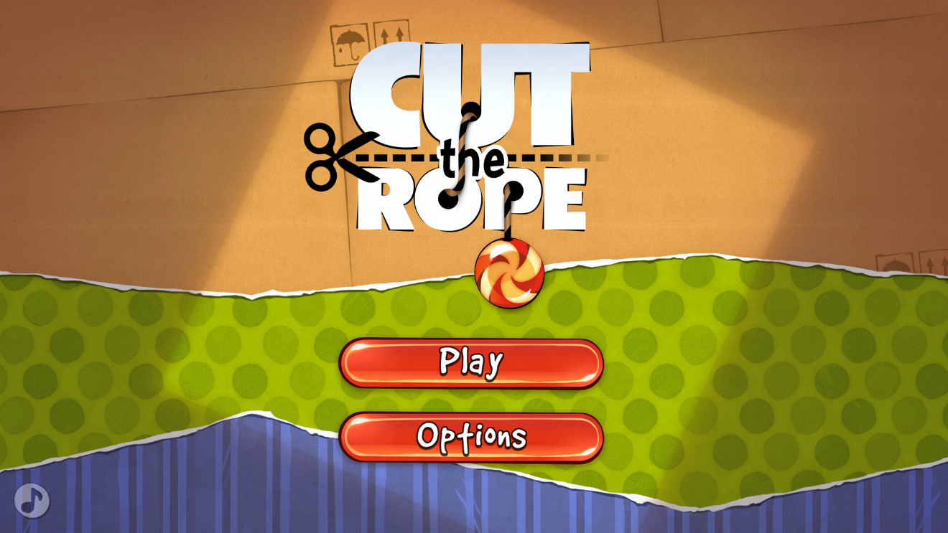
SYSTEM REQUIREMENTS :

Hardware Requirements:
- Pentium processor/higher with 2 GB RAM
- Mouse
- Keyboard
- Colour monitor

Software Requirements:
- Operating system – Windows XP or higher
- Python version 2.7.4 or higher
- 3D OpenGL compatible graphics accelerator card.
- 256 MB RAM.
- 500 Mhz Pentium 3 processor.
Recommendations:
- A late-model 3D OpenGL compatible graphics accelerator card from nVidia, ATI, 3Dlabs or similar.
- 512 MB RAM (768 MB or 1 GB preferred).
- 3 Ghz Pentium 4 processor or similar.

MODULES AND FUNCTIONS USED :

Modules:
- pygame module
- math module
- Time module
Library functions:
- pygame init() – to initialize the pygame module.

- mixer.init() – to initialize the mixer sound options.

- mixer.music.load(file) – to load the playback music file.

- mixer.music.play(file) – to play the music loaded.

- mixer.music.get_busy() – to check whether the mixer is in use.

- mixer.music.stop() – to stop playing the playback music.

- surface.blit() – to render the background object on the screen.

- display.set_mode((x,y)) –to create a window of required size.

- display.set_caption(caption) –to set the title for the window created.

- display.update() – to update the screen from time to time.

- time.Clock() – to have an access to time.

- image.load(image) – to load the image required as an object.

- pygame.transform.scale(object,(x,y)) – to transform the image to a required size.

- event.get() – to get the state of various input devices.

- mouse.get_pos() – to get the position of mouse at any instant of time.

- draw.circle(screen,color,(x,y)<center>,radius,thickness) – to draw a circle of required dimension on the screen.

- draw.lines(screen,color,closed<True/False>,pointlist,thickness) – to draw lines on the screen.

- quit() – to exit from the window created.

- math.sin(angle) – to obtain sine of an angle.

- math.cos(angle) – to obtain cosine of an angle.

- time. sleep() – to make the delay.

GAME FLOWCHART :

Sound options

main menu

level select

play game

score card

play

USER DEFINED FUNCTIONS AND DATA TYPES USED IN THE CODE :
- Sound(): It takes no parameters. It is evoked to control the play back music options such as on and off.
- Menu(): It takes no parameters. It is evoked to control and to facilitate the main menu options such as play and quit.
- LevelSelect(): It takes no parameters. It is evoked to control and facilitate the level selection options.
- swing(): It takes 6 parameters. It is responsible for the swinging action of the candy. It returns the angle with vertical, tangential velocities of the candy and the new position of candy each time this function is invoked.
- Result(): It takes 1 parameter. This function calculates the score and displays the number of stars collected if won. If lost , allows you to try again .
- Fall(): It takes 13 parameters in which 3 are default parameters. This function takes the responsibility of motion of candy after being cut. It takes care of the normal freefall after being cut ,the bubble floating up, checking whether the bubble gets popped, checking for stars and check whether the bowl has been reached or whether the target has been missed. It returns a Boolean value True or False whether the target has been reached or not .
- check_star(): It takes 2 parameters. This is a function that checks whether the star has been caught by the candy or not. It does not return any value.
- blit():
- cut(): It takes 4 parameters. This function checks whether the rope of the candy has been cut or not. It returns a Boolean value True if cut, otherwise False.
- Game_Loop(): It takes 9 parameters. This function is the main game loop that handles the levels of the game. It does not return any value.
- render_textrect(): Returns a surface containing the passed text string, reformatted to fit within the given rectangle , word-wrapping as necessary. The text will be anti-aliased.

VARIABLES USED AND THEIR DATATYPES:

VARIABLE | DATATYPE
file | string
white | tuple
black | tuple
blue | tuple
red | tuple
display_h | int
candy_width | int
display_w | int
mx | float
my | float
x | float
y | float
cx | float
cy | float
r | float
ay | float
t | float
angle | float
angle_max | float
yn | float
xn | float
vx | float
vy | float
win | boolean
time_taken | float
num_stars | int
scor | int
font_size | int
a | float
x_bowl | float
y_bowl | float
cont | boolean
h | float
occupied | boolean
exist | boolean
x_centre | float
y_centre | float
r_candy | float
x_bowl | float
y_bowl | float
acc | int
dt | float
final_lines | list
words | list
c | int
n | string
accumulated_line | string
l1 | Object of class levels
l2 | Object of class levels
l3 | Object of class levels
check | int
S1 | Object of class stars
S2 | Object of class stars
S3 | Object of class stars

SOURCE CODE :

# importing all required modules
import pygame
import math
import time
import pickle
#initialising pygame
pygame.init()
file = '123.mp3'
pygame.mixer.init()
pygame.mixer.music.load(file)
pygame.mixer.music.play()
#colours
white = (255,255,255)
black = (0,0,0)
red = (255,0,0)
blue = (0,0,255)
#etc

# max height is, say, 2000 (for window)
display_h = 800
display_w = int(display_h*1.2)
# creating the screen window
surface = pygame.display.set_mode((display_w,display_h))
pygame.display.set_caption("Cut The Rope")
#creating clock to track time
clock=pygame.time.Clock()
# note : max img size=2000/20
candy_width = int(display_h/20)

#creating objects for the images required
candy = pygame.image.load('CANDY.png')
bowl=pygame.image.load('bowl1.png')
##bwc=pygame.image.load('bowl and candy.png')
stari=pygame.image.load('star2.png')
menu = pygame.image.load('menu.png')
back = pygame.image.load('back6.png')
back1 = pygame.image.load('back1.png')
sound_on = pygame.image.load('sound_on.png')
sound_off = pygame.image.load('sound_off.png')
levelselect = pygame.image.load('level select.png')
score1 = pygame.image.load('s1.png')
score2 = pygame.image.load('s2.png')
score3 = pygame.image.load('s3.png')
score0 = pygame.image.load('s0.png')
go2menu = pygame.image.load('go2menu.png')
playagain = pygame.image.load('playagain.png')
nextlevel = pygame.image.load('nextlevel.png')
hat1 = pygame.image.load('redhat.png')
hat2 = pygame.image.load('bluehat.png')

#transforming images to the sizes required
candy = pygame.transform.scale(candy,(candy_width,candy_width))
bowl = pygame.transform.scale(bowl,((candy_width*4,candy_width*4)))
stari= pygame.transform.scale(stari,(candy_width,candy_width))
menu = pygame.transform.scale(menu,(display_w,display_h))
back = pygame.transform.scale(back,(display_w,display_h))
back1 = pygame.transform.scale(back1,(display_w,display_h))
sound_on = pygame.transform.scale(sound_on,(int(display_w*0.30576923),int(display_h*0.1358975)))
sound_off = pygame.transform.scale(sound_off,(int(display_w*0.30576923),int(display_h*0.1358975)))
levelselect = pygame.transform.scale(levelselect,(int(display_h*0.7),int(display_h*0.8)))
score1 = pygame.transform.scale(score1,(int(candy_width*6),int(candy_width*1.6236)))
score2 = pygame.transform.scale(score2,(int(candy_width*6),int(candy_width*1.6236)))
score3 = pygame.transform.scale(score3,(int(candy_width*6),int(candy_width*1.6236)))
score0 = pygame.transform.scale(score0,(int(candy_width*6),int(candy_width*1.6236)))
go2menu = pygame.transform.scale(go2menu,(int(candy_width*4),int(candy_width*2)))
nextlevel = pygame.transform.scale(nextlevel,(int(candy_width*4),int(candy_width*2)))
playagain = pygame.transform.scale(playagain,(int(candy_width*4),int(candy_width*2)))
hat1 = pygame.transform.scale(hat1,(int(candy_width*2),int(candy_width*2)))
hat2 = pygame.transform.scale(hat2,(int(candy_width*2),int(candy_width*2)))
hat1 = pygame.transform.rotate(hat1,170)

#001
#For background sound options ON or OFF
def Sound():
if pygame.mixer.music.get_busy():
surface.blit(menu, (0, 0))
surface.blit(sound_off,(display_h/2.425373,display_h/1.340206))
pygame.mixer.music.stop()
pygame.display.update()
else:
surface.blit(menu, (0, 0))
surface.blit(sound_on,(display_h/2.425373,display_h/1.340206))
pygame.mixer.music.play()
pygame.display.update()

#002
#For managing the menu window
def Menu():
surface.blit(menu, (0, 0))
for event in pygame.event.get():
if event.type == pygame.QUIT:
pygame.quit()
quit()
surface.blit(sound_on,(int(display_h/2.425373),int(display_h/1.340206)))
pygame.display.update()
global sound_state
c = 0
while 1:
for event in pygame.event.get():
if event.type == pygame.QUIT:
pygame.quit()
quit()
if event.type == pygame.MOUSEBUTTONUP:
(mx,my) = pygame.mouse.get_pos()
if int(mx) in range(int(display_h/2.32142857),int(display_h/1.3)) and int(my) in range(int(display_h/1.3131313),int(display_h/1.17117117)):
Sound() # calling 001
if int(mx) in range(int(display_h/2.32142857),int(display_h/1.3)) and int(my) in range(int(display_h/1.547619),int(display_h/1.35416667)):
c = 1
break
if int(mx) in range(int(display_h/1.2),int(display_h/1.05)) and int(my) in range(int(display_h/1.547619),int(display_h/1.35416667)):
print 'here'
fo=open('Highscores.DAT','rb')
L=[]
try:
L+=[pickle.load(fo)]
except:
fo.close()
for i in L:
print i.name,'\t',i.score
if c:
break
LevelSelect()

# to handle level selection
def LevelSelect():
global level
surface.blit(levelselect,(int(display_h*0.6-display_h*0.35),display_h*0.1))
pygame.display.update()
while 1:
for event in pygame.event.get():
if event.type == pygame.QUIT:
pygame.quit()
quit()
if event.type == pygame.MOUSEBUTTONUP:
(mx,my) = pygame.mouse.get_pos()
if int(mx) in range(int(display_h/2.15),int(display_h/1.36)) and int(my) in range(int(display_h/5),int(display_h/3.6)):
l1.time_start = time.time()
level = l1
l1.Play_Level()
if int(mx) in range(int(display_h/2.15),int(display_h/1.36)) and int(my) in range(int(display_h/2.5),int(display_h/2.07)):
l2.time_start = time.time()
level = l2
l2.Play_Level()
if int(mx) in range(int(display_h/2.15),int(display_h/1.36)) and int(my) in range(int(display_h/1.67),int(display_h/1.46)):
l3.time_start = time.time()
level = l3
l3.Play_Level()
#003
#For swinging movement of the candy
def swing((x,y), (cx,cy), r, ay, dt, t):
global check
global angle_max
angle_max *= 0.9995
angle = angle_max * math.sin((ay/r)**1/2 * (t+2.5))
yn = r * math.cos(angle) + cy
xn = r * math.sin(angle) + cx
vx =(xn - x)/dt
vy = (yn - y)/dt
return (xn,yn),angle,[vx,vy]

#004
# to calculate scorecard if won
def Result(win):
time.sleep(1.5)
global level
if win:
time_taken = time.time()-level.time_start
num_stars = 0
for i in [s1,s2,s3]:
if not i.exist:
num_stars += 1
scor = int(10*(200+200 * num_stars )/ time_taken)
scor = score(scor)
scor.check_high()
font_size = pygame.font.Font('freesansbold.ttf',int(candy_width/2))
WIN = font_size.render('YOU WIN! CONGRATS =)', True, black)
scortxt = font_size.render('Score: '+str(scor.score),True,black)
WIN_Rect = WIN.get_rect()
WIN_Rect.center = (int(display_w/2), int(display_h/2-candy_width*3))
score_Rect = scortxt.get_rect()
score_Rect.center = ((display_w/2), (display_h/2-candy_width*2))
surface.blit(back,(0,0))
surface.blit(WIN, WIN_Rect)
surface.blit(scortxt,score_Rect)
if num_stars == 0:
surface.blit(score0,(int(display_w/2-candy_width*3), int(display_h/2-candy_width)))
elif num_stars == 1:
surface.blit(score1,(int(display_w/2-candy_width*3), int(display_h/2-candy_width)))
elif num_stars == 2:
surface.blit(score2,(int(display_w/2-candy_width*3), int(display_h/2-candy_width)))
elif num_stars == 3:
surface.blit(score3,(int(display_w/2-candy_width*3), int(display_h/2-candy_width)))
if level.level == 3:
surface.blit(playagain,(int(display_w/2-candy_width*2), int(display_h/2+candy_width*3)))
surface.blit(go2menu,(int(display_w/2-candy_width*2), int(display_h/2+candy_width*5)))
pygame.display.update()
while 1:
for event in pygame.event.get():
if event.type == pygame.QUIT:
pygame.quit()
quit()
if event.type == pygame.MOUSEBUTTONUP:
(mx,my) = pygame.mouse.get_pos()
if int(mx) in range(int(display_w/2-candy_width*2),int(display_w/2+candy_width*2)):
if int(my) in range(int(display_h/2+candy_width*3),int(display_h/2+candy_width*5)):
level.time_start = time.time()
level.Play_Level()
if int(mx) in range(int(display_w/2-candy_width*2),int(display_w/2+candy_width*2)):
if int(my) in range(int(display_h/2+candy_width*5),int(display_h/2+candy_width*7)):
Menu()

else:
surface.blit(playagain,(int(display_w/2-candy_width*4.5), int(display_h/2+candy_width*3)))
surface.blit(nextlevel,(int(display_w/2+candy_width*0.5), int(display_h/2+candy_width*3)))
surface.blit(go2menu,(int(display_w/2-candy_width*2), int(display_h/2+candy_width*5)))
pygame.display.update()
while 1:
for event in pygame.event.get():
if event.type == pygame.QUIT:
pygame.quit()
quit()
if event.type == pygame.MOUSEBUTTONUP:
(mx,my) = pygame.mouse.get_pos()
if int(mx) in range(int(display_w/2-candy_width*4.5),int(display_w/2-candy_width*0.5)):
if int(my) in range(int(display_h/2+candy_width*3),int(display_h/2+candy_width*5)):
level.time_start = time.time()
level.Play_Level()
if int(mx) in range(int(display_w/2+candy_width*0.5),int(display_w/2+candy_width*4.5)):
if int(my) in range(int(display_h/2+candy_width*3),int(display_h/2+candy_width*5)):
if level.level == 1:
level = l2
elif level.level == 2:
level = l3
level.time_start = time.time()
level.Play_Level()
if int(mx) in range(int(display_w/2-candy_width*2),int(display_w/2+candy_width*2)):
if int(my) in range(int(display_h/2+candy_width*5),int(display_h/2+candy_width*7)):
Menu()

else:
surface.blit(back,(0,0))
font_size = pygame.font.Font('freesansbold.ttf',candy_width/2)
LOSE = font_size.render('Oops. Try again!', True, black)
LOSE_Rect = LOSE.get_rect()
LOSE_Rect.center = ((display_w/2), (display_h/2 - candy_width*2))
surface.blit(LOSE, LOSE_Rect)
surface.blit(playagain,(int(display_w/2-candy_width*2), int(display_h/2)))
surface.blit(go2menu,(int(display_w/2-candy_width*2), int(display_h/2+candy_width*2)))
pygame.display.update()
while 1:
for event in pygame.event.get():
if event.type == pygame.QUIT:
pygame.quit()
quit()
if event.type == pygame.MOUSEBUTTONUP:
(mx,my) = pygame.mouse.get_pos()
if int(mx) in range(int(display_w/2-candy_width*2),int(display_w/2+candy_width*2)):
if int(my) in range(int(display_h/2),int(display_h/2+candy_width*2)):
level.time_start = time.time()
level.Play_Level()
if int(mx) in range(int(display_w/2-candy_width*2),int(display_w/2+candy_width*2)):
if int(my) in range(int(display_h/2+candy_width*2),int(display_h/2+candy_width*4)):
Menu()

#005
# to handle the motion of candy after being cut
def fall((x,y),angle, v, a, dt, t,x_bowl,y_bowl, xc, yc, xc2=0, yc2=0, r2=0):
global s1,s2,s3,r,h1,h2,hi1,hi2
cont = True
t_h = 0
while cont:
c=0
#For normal freefall, not within bubble - r (r for ring)
if r.occupied==False:
x += v[0]*dt
y += v[1]*dt
v[1] += a*dt
for event in pygame.event.get():
if event.type == pygame.QUIT:
pygame.quit()
quit()
#For bubble floating up
else:
v0=200 #some const speed in bubble
y -= 200*dt
r.y=y+5
v[0] = 0
v[1] = 0
#checking if bubble is getting popped
for event in pygame.event.get():
if event.type == pygame.QUIT:
pygame.quit()
quit()
elif event.type == pygame.MOUSEBUTTONUP:
pos = pygame.mouse.get_pos()
if int(pos[0]) in range(int(r.x-candy_width/2-5),int(r.x+candy_width/2+5)):
if int(pos[1]) in range(int(r.y-candy_width/2-5),int(r.y+candy_width/2+5)):
r.occupied = False
r.exist = False
blit(back,(x,y),(x_bowl,y_bowl),(xc,yc),False,xc2,yc2,v)
pygame.display.update()
clock.tick(100)

#falling out of screen
if y > display_h+candy_width or x > display_w+candy_width or x < -candy_width or y < -candy_width:
cont = False
Result(False)
t+=dt

#checking for stars
check_star(x,y)

#check for hat
for h in (h1,h2,hi1,hi2):
if h.exist:
if int(x) in range(h.pos1[0]-candy_width,h.pos1[0]+candy_width*2):
if int(y) in range(h.pos1[1]-candy_width,h.pos1[1]+candy_width*2):
if h.d1 == 'u' and v[1]>0:
surface.blit(h.img1,h.pos1)
pygame.display.update()
if t>t_h+0.5 and int(x) in range(int(h.pos1[0]-candy_width*0.2),int(h.pos1[0]+candy_width*1.2)):
if int(y) in range(h.pos1[1],h.pos1[1]+candy_width):
t_h = t
(x,y) = h.pos2
if h.d2 == 'u':
v[0],v[1] = 0,-v[1]
if h.d2 == 'l':
v[0],v[1] = -v[1],0
if h.d2 == 'r':
v[0],v[1] = v[1],0
else:
v[0],v[1] = 0,v[1]
if h.d1 == 'l' and v[0]>0:
surface.blit(h.img1,h.pos1)
pygame.display.update()
if t>t_h+0.5 and int(x) in range(h.pos1[0],h.pos1[0]+candy_width):
if int(y) in range(int(h.pos1[1]-candy_width*0.2),int(h.pos1[1]+candy_width*1.2)):
t_h = t
(x,y) = h.pos2
if h.d2 == 'u':
v[0],v[1] = 0,-v[0]
if h.d2 == 'l':
v[0],v[1] = -v[0],0
if h.d2 == 'd':
v[0],v[1] = 0,v[0]
else:
v[0],v[1] = v[0],0
if h.d1 == 'r' and v[0]<0:
surface.blit(h.img1,h.pos1)
pygame.display.update()
if t>t_h+0.5 and int(x) in range(h.pos1[0],h.pos1[0]+candy_width):
if int(y) in range(int(h.pos1[1]-candy_width*0.2),int(h.pos1[1]+candy_width*1.2)):
t_h = t
(x,y) = h.pos2
if h.d2 == 'u':
v[0],v[1] = 0,v[0]
if h.d2 == 'd':
v[0],v[1] = 0,-v[0]
if h.d2 == 'r':
v[0],v[1] = -v[0],0
else:
v[0],v[1] = v[0],0
if h.d1 == 'd' and v[1]<0:
surface.blit(h.img1,h.pos1)
pygame.display.update()
if t>t_h+0.5 and int(x) in range(int(h.pos1[0]-candy_width*0.2),int(h.pos1[0]+candy_width*1.2)):
if int(y) in range(h.pos1[1],h.pos1[1]+candy_width):
t_h = t
(x,y) = h.pos2
if h.d2 == 'd':
v[0],v[1] = 0,-v[1]
if h.d2 == 'l':
v[0],v[1] = v[1],0
if h.d2 == 'r':
v[0],v[1] = -v[1],0
else:
v[0],v[1] = 0,v[1]

#check for bubble if not already inside
if r.occupied == False and r.exist == True:
for i in range(int(r.x-candy_width*1.8), int(r.x+candy_width*0.8)):
if i==int(x):
for j in range(int(r.y-candy_width*0.8), int(r.y+candy_width*0.8)):
if j==int(y):
r.occupied = True
x,y=r.x-candy_width/2,r.y-candy_width/2

#check for bowl
for i in range(int(x_bowl-candy_width/2),int(x_bowl+candy_width*2.8)):
if i==int(x):
for i in range(int(y_bowl+candy_width*0.2),y_bowl+candy_width):
if i==int(y):
c=1
if c==1:
cont=False
Result(True)

#function to check if candy hits star
def check_star(x,y):
global s1,s2,s3
for s in [s1,s2,s3]:
for i in range(int(s.x-candy_width*0.8), int(s.x+candy_width*0.8)):
if i==int(x):
for j in range(int(s.y-candy_width*0.8), int(s.y+candy_width*0.8)):
if j==int(y):
s.exist = False

def blit(back,(x,y),(xb,yb),(xc,yc),sw=False,xc2=0,yc2=0,v=[0,0]):
global s1,s2,s3,r,h1,h2
surface.blit(back,(0,0))
surface.blit(bowl,(xb,yb))
if s1.exist==True:
surface.blit(s1.img,(s1.x,s1.y))
if s2.exist==True:
surface.blit(s2.img,(s2.x,s2.y))
if s3.exist==True:
surface.blit(s3.img,(s3.x,s3.y))
if r.exist==True:
pygame.draw.circle(surface,blue,(int(r.x),int(r.y)),int(candy_width*0.5+30),10)
if sw==True:
pygame.draw.lines(surface, black, False,[(x+candy_width/2, y+candy_width/2),(xc+candy_width/2, yc+candy_width/2)], 2)
pygame.draw.circle(surface,black,[xc+20,yc+20],5,5)
if xc2 and yc2:
pygame.draw.circle(surface,black,[xc2+20,yc2+20],5,5)
if h1.exist:
surface.blit(h1.img1,h1.pos1)
surface.blit(h1.img2,h1.pos2)
if h2.exist:
surface.blit(h2.img1,h2.pos1)
surface.blit(h2.img2,h2.pos2)
surface.blit(candy,(x,y))

#006
# to check whether the rope is cut or not
def cut(x_candy,y_candy,xc,yc):
for event in pygame.event.get():
if event.type == pygame.QUIT:
pygame.quit()
quit()
elif event.type == pygame.MOUSEMOTION:
pygame.mouse.set_visible(True)
ctr=0
(x,y)=event.pos
if x_candy>xc:
for i in range(xc,int(x_candy)):
if i==x:
ctr=1
elif x_candy<xc:
for i in range(int(x_candy),xc):
if i==x:
ctr=1
if ctr==1:
for i in range(yc,int(y_candy)):
if i==y:
ctr=2
if ctr==2:
return True
else:
return False
else:
return False

#007
# main game loop
def Game_Loop(l, x_center, y_center, r_candy, x_bowl, y_bowl, x_center2, y_center2, r_candy2):
global angle_max
global s1,s2,s3
angle_max = (math.pi/2)
x_candy = x_center + r_candy
y_candy = y_center
dt = 0.01
t = 0
angle = 0
vel=[0,0]
if l == 1:
acc = 800
elif l == 2:
acc = 1000
elif l == 3:
acc = 1100
else:
print "ERROR: unidentifyable level"
time.sleep(5)
while 1:
check_star(x_candy,y_candy)
if cut(x_candy,y_candy,x_center,y_center):
break
else:
((x_candy, y_candy), angle, vel) = swing((x_candy,y_candy),(x_center, y_center), r_candy, acc, dt, t)
blit(back,(x_candy,y_candy),(x_bowl,y_bowl),(x_center,y_center),True,x_center2,y_center2)
pygame.display.update()
clock.tick(100)
t += dt
fall((x_candy, y_candy),angle, vel, acc, dt, t, x_bowl,y_bowl,x_center,y_center, x_center2, y_center2, r_candy2)

class TextRectException:
def __init__(self, message = None):
self.message = message
def __str__(self):
return self.message

def render_textrect(string, font, rect, text_color, background_color, justification=0):
"""Returns a surface containing the passed text string, reformatted
to fit within the given rect, word-wrapping as necessary. The text
will be anti-aliased.”””

“””Takes the following arguments:
string - the text you wish to render. \n begins a new line.
font - a Font object
rect - a rectstyle giving the size of the surface requested.
text_color - a three-byte tuple of the rgb value of the
text color. ex (0, 0, 0) = BLACK
background_color - a three-byte tuple of the rgb value of the surface.
justification - 0 (default) left-justified
1 horizontally centered
2 right-justified
Returns the following values:
Success - a surface object with the text rendered onto it.
Failure - raises a TextRectException if the text won't fit onto the surface.
"""

import pygame
final_lines = []
requested_lines = string.splitlines()
# Create a series of lines that will fit on the provided
# rectangle.
for requested_line in requested_lines:
if font.size(requested_line)[0] > rect.width:
words = requested_line.split(' ')
# if any of our words are too long to fit, return.
for word in words:
if font.size(word)[0] >= rect.width:
raise TextRectException, "The word " + word + " is too long to fit in the rect passed."
# Start a new line
accumulated_line = ""
for word in words:
test_line = accumulated_line + word + " "
# Build the line while the words fit.
if font.size(test_line)[0] < rect.width:
accumulated_line = test_line
else:
final_lines.append(accumulated_line)
accumulated_line = word + " "
final_lines.append(accumulated_line)
else:
final_lines.append(requested_line)

# Let's try to write the text out on the surface.
surface = pygame.Surface(rect.size)
surface.fill(background_color)
accumulated_height = 0
for line in final_lines:
if accumulated_height + font.size(line)[1] >= rect.height:
raise TextRectException, "Once word-wrapped, the text string was too tall to fit in the rect."
if line != "":
tempsurface = font.render(line, 1, text_color)
if justification == 0:
surface.blit(tempsurface, (0, accumulated_height))
elif justification == 1:
surface.blit(tempsurface, ((rect.width - tempsurface.get_width()) / 2, accumulated_height))
elif justification == 2:
surface.blit(tempsurface, (rect.width - tempsurface.get_width(), accumulated_height))
else:
raise TextRectException, "Invalid justification argument: " + str(justification)
accumulated_height += font.size(line)[1]
return surface
#Class for levels-b(bowl),s(star),r(ring/bubble),c(centre of rotation 1),c2(centre of rotation #2),r(radius of swing)
class levels(object):
def __init__(self,l,xb,yb,xs1,ys1,xs2,ys2,xs3,ys3,xr,yr,xh11,yh11,xh12,yh12,d11,d12,xh21,yh21,xh22,yh22,d21,d22,xc,yc,r,xc2=0,yc2=0,r2=0):
self.level = l
self.xb = xb
self.yb = yb
self.xs1 = xs1
self.ys1 = ys1
self.xs2 = xs2
self.ys2 = ys2
self.xs3 = xs3
self.ys3 = ys3
self.r = r
self.xc = xc
self.yc = yc
self.r2 = r2
self.xc2 = xc2
self.yc2 = yc2
self.xr = xr
self.yr = yr
self.xh11 = xh11
self.yh11 = yh11
self.xh12 = xh12
self.yh12 = yh12
self.d11 = d11
self.d12 = d12
self.xh21 = xh21
self.yh21 = yh21
self.xh22 = xh22
self.yh22 = yh22
self.d21 = d21
self.d22 = d22
#function to invoke game play for respective level
def Play_Level(self):
global s1,s2,s3,r,h1,h2,hi1,hi2
s1 = star(self.xs1,self.ys1)
s2 = star(self.xs2,self.ys2)
s3 = star(self.xs3,self.ys3)
r = ring(self.xr,self.yr)
h1 = hat(self.xh11,self.yh11,self.xh12,self.yh12,self.d11,self.d12,hat1)
hi1 = hat(self.xh12,self.yh12,self.xh11,self.yh11,self.d12,self.d11,hat1)
h2 = hat(self.xh21,self.yh21,self.xh22,self.yh22,self.d21,self.d22,hat2)
hi2 = hat(self.xh22,self.yh22,self.xh21,self.yh21,self.d22,self.d21,hat2)
if r.x==0 and r.y==0:
r.exist = False
Game_Loop(self.level, self.xc, self.yc, self.r, self.xb, self.yb, self.xc2, self.yc2, self.r2)

#star as an object
class star:
def __init__(self,x,y):
self.img = stari
self.x = x
self.y = y
self.exist = True

#ring as an object
class ring:
def __init__(self,x,y):
self.occupied = False
self.x = x
self.y = y
self.exist = True

class hat:
def __init__(self,x1,y1,x2,y2,dir1,dir2,hat):
self.pos1 = (x1,y1)
self.pos2 = (x2,y2)
self.d1 = dir1 #angle wrt upwards facing,anti-clockwise
self.d2 = dir2
if x1 or y1 or x2 or y2:
self.exist = True
if self.d1 == 'r':
self.img1 = pygame.transform.rotate(hat,-90)
elif self.d1 == 'l':
self.img1 = pygame.transform.rotate(hat,90)
elif self.d1 == 'u':
self.img1 = hat
elif self.d1 == 'd':
self.img1 = pygame.transform.rotate(hat,180)
else:
print 'Not correct direction for hat!'
if self.d2 == 'r':
self.img2 = pygame.transform.rotate(hat,-90)
elif self.d2 == 'l':
self.img2 = pygame.transform.rotate(hat,90)
elif self.d2 == 'u':
self.img2 = hat
elif self.d2 == 'd':
self.img2 = pygame.transform.rotate(hat,180)
else:
print 'Not correct direction for hat!'
else:
self.exist = False

def get_name():
c=1
font_size = pygame.font.Font('freesansbold.ttf',int(candy_width/2))
n=''
while c:
surface.blit(back,(0,0))
s = 'HIGHSCORE!! Please enter your name: '
high = font_size.render(s+n, True, black)
Rect = high.get_rect()
Rect.center = (int(display_w/2), int(display_h/2-candy_width))
surface.blit(high, Rect)
pygame.display.update()
for event in pygame.event.get():
if event.type == pygame.QUIT:
pygame.quit()
quit()
if event.type == pygame.KEYDOWN:
if event.key == pygame.K_RETURN:
c=0
break
lst = pygame.key.get_pressed()
for i in range(len(lst)):
if lst[i]:
n+=str(unichr(i))
break
return n

class score:
def __init__(self,score):
self.score = score
self.level = level
def check_high(self):
fo = open('Highscores.DAT','rb')
L=[]
try:
L+=[pickle.load(fo)]
except:
print 'closed'
fo.close()
print L
if len(L)==1:
if L[0]<self.score:
print 2
self.name = get_name()
L.insert(0,self)
else:
self.name = get_name()
L.insert(1,self)
else:
for i in range(len(L)-2,-1,-1):
if L[i].level==self.level:
if L[i].score>self.score:
print 1
if L[i+1]<self.score:
print 2
self.name = get_name()
L.insert(i+1,self)
break
else:
print 3
break
else:
print 4
self.name = get_name()
L.insert(0,self)
if len(L)>3:
print 5
del L[-1]
fo = open('Highscores.DAT','wb')
for i in L:
print 6
pickle.dump(i,fo)
fo.close()

##initialising
l1=levels(1,550,500,280,330,350,350,400,400,0,0,0,0,0,0,'','',0,0,0,0,'','',200,200,150,0,0,0)
l1=levels(1,500,500,330,270,400,250,460,300,0,0,0,0,0,0,'','',0,0,0,0,'','',200,200,150,0,0,0)
l2=levels(2,677-candy_width*2,600,450,250,650,135,345,252,677,406,0,0,0,0,'','',0,0,0,0,'','',200,50,200,0,0,0)
l3=levels(3,450,500,330,270,200,100,460,300,250,500,200,350,600,400,'d','l',200,600,500,300,'u','d',200,200,150,0,0,0)
angle_max = (math.pi/2)
check=0
level = None

#starting game
fo = open('Instructions.txt')
r = '\n\n'+fo.read()
fo.close()
font_size = pygame.font.Font('freesansbold.ttf',30)
instr = font_size.render(r, True, black)
##Rect = instr.get_rect()
##Rect.center = (int(display_w/2), int(display_h/2-candy_width*3))
surface.blit(back1,(0,0))
Rect = pygame.Rect((25, 25, display_w-50, display_h-50))
rendered_text = render_textrect(r, font_size, Rect, (216, 216, 216), (48, 48, 48), 1)
if rendered_text:
surface.blit(rendered_text, Rect.topleft)
pygame.display.update()

c=1
while c:
for event in pygame.event.get():
if event.type == pygame.QUIT:
pygame.quit()
quit()
if event.type == pygame.KEYUP:
c=0
Menu()

Screen shots of outputs :

# initial instructions to the player
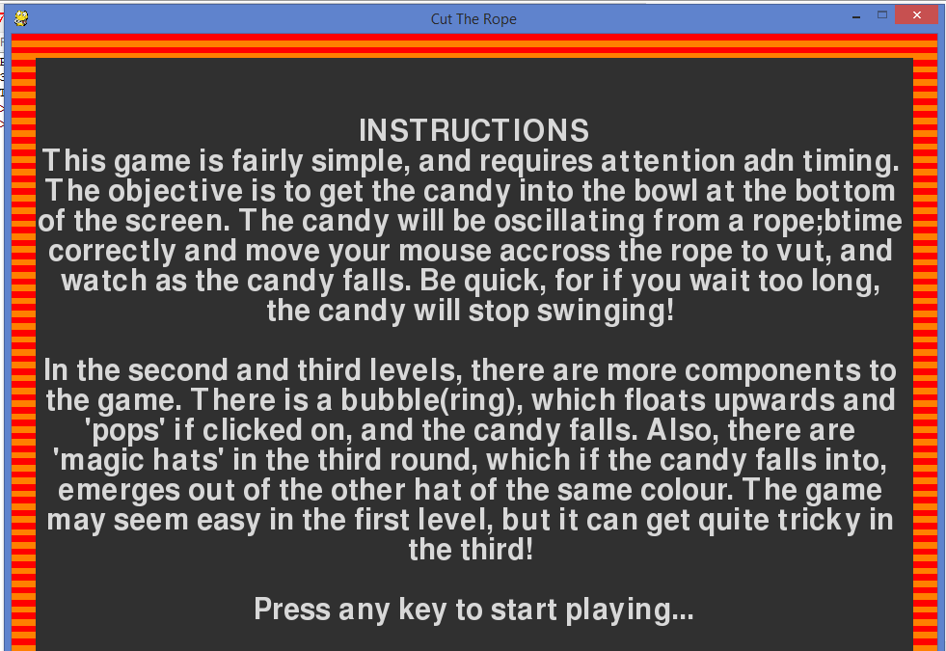

# menu selection option
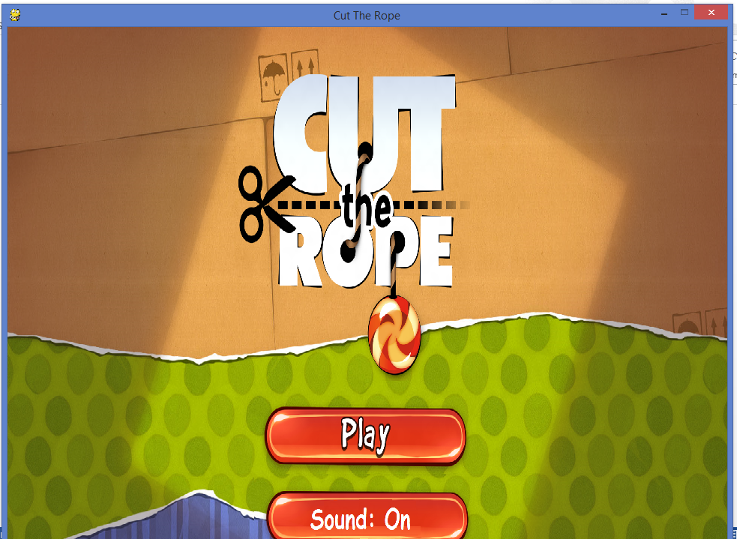

# level selection option
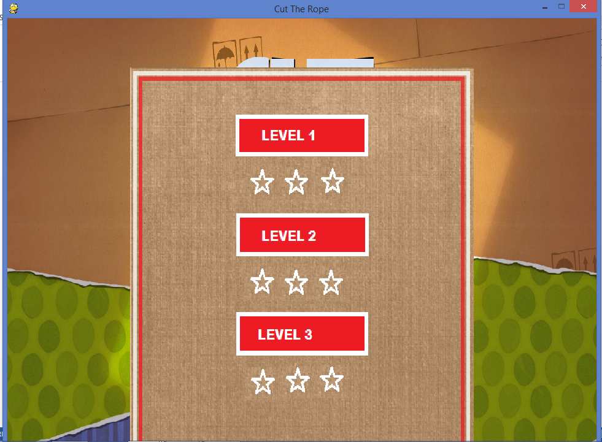

# level 1
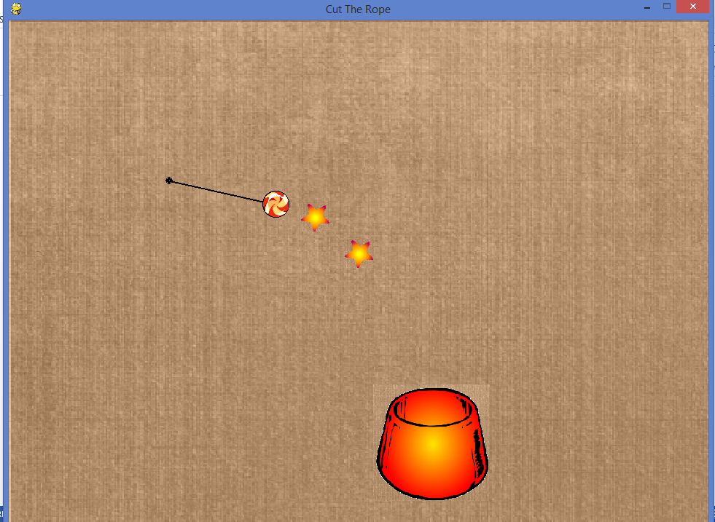

# level 2
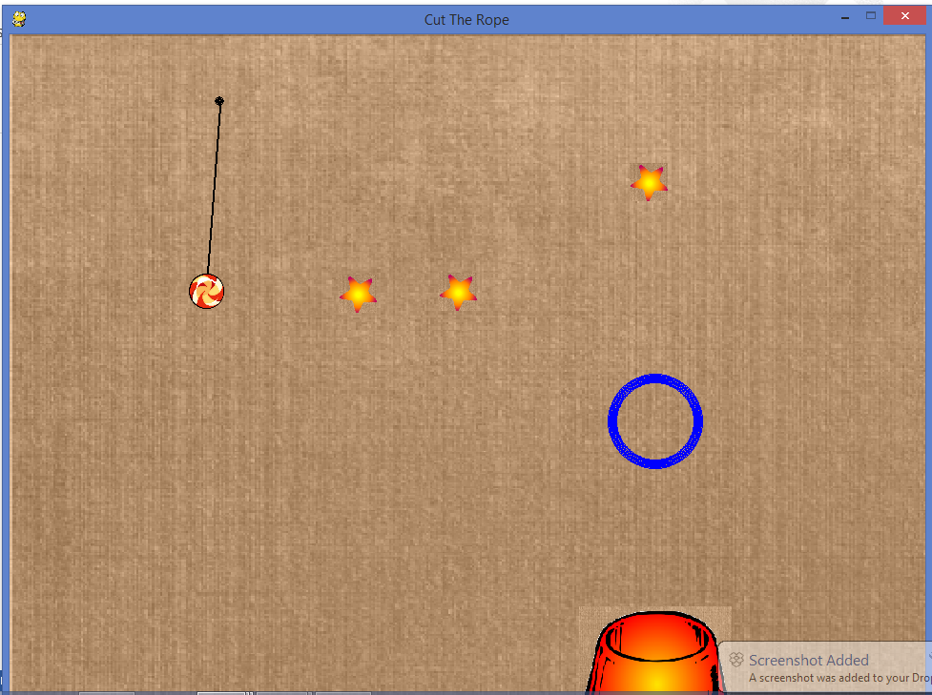

# level 3
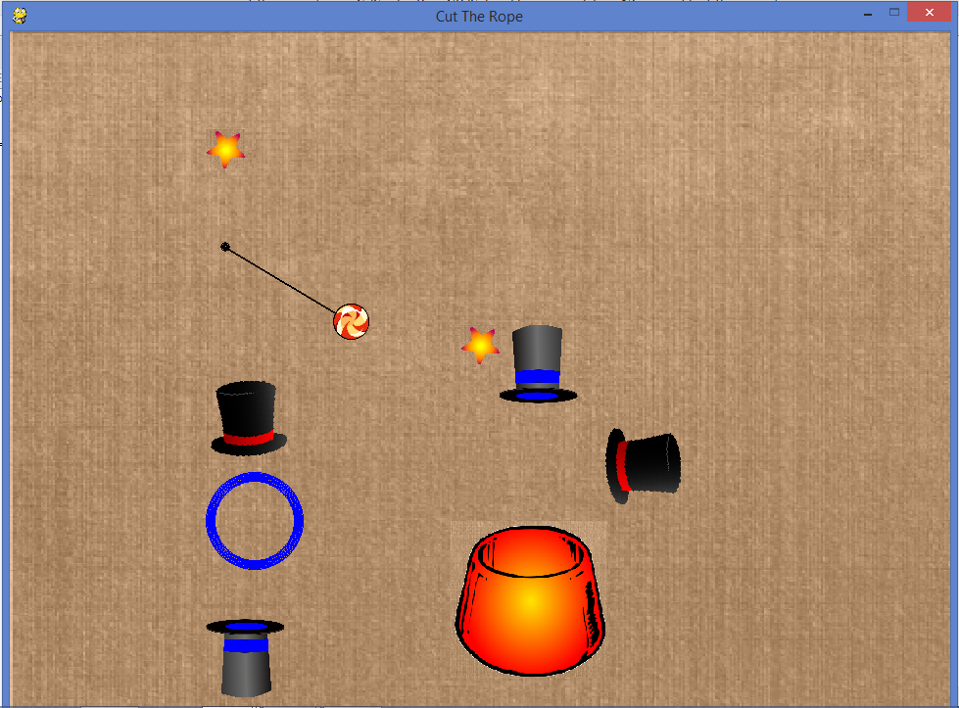

# if game lost
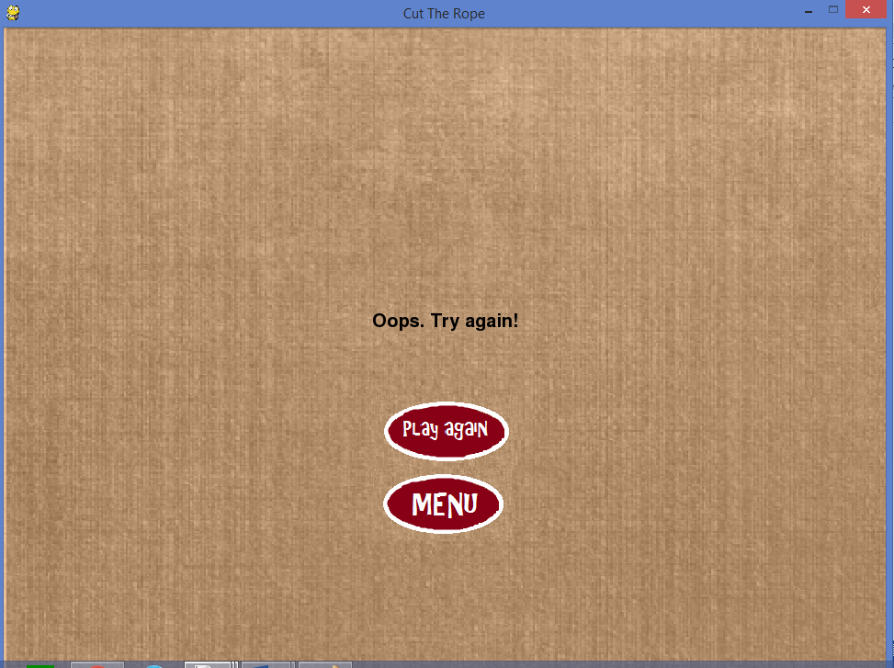

Bibliography :

- www.pygame.org/
- www.stackoverflow.com/
- https://pythonprogramming.net/pygame-python-3-part-1-intro/
- https://www.youtube.com/watch

